ST THOMAS SCHOOL, DHURWA, RANCHI
ANNUAL TERMINAL, SESSION 2020 – 2021
CLASS : V SUBJECT: SCIENCE

Chapter 4 Pollination ( Answers)
Exercise 1. Choose the correct answer.
- Pedicel
- Ovary
- Pollen grain
- Petals
- Wind
Exercise 2. Write True or False.
- True
- True
- False
- False
- False
Exercise 3. Give two examples of each.
- Gulmohar, Hibiscus
- Papaya, Cucumber
- Sunflower, Orchids
- Rice, Maize
- Vallisneria, Hydrilla
Exercise 4. Short answer questions.
- The swollen end of the pedicel is called the thalamus.
- The four parts of a flower are – Calyx, Corolla, Androecium and Gynoecium.
- The male gametes of flowers are found in the pollen grains while the female gametes are found in the ovules.
- Bright colours and fragrance are the two characteristics of insect pollinated flowers.
- 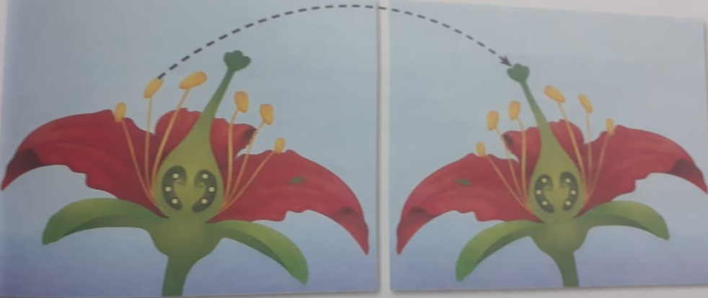Cross – pollination

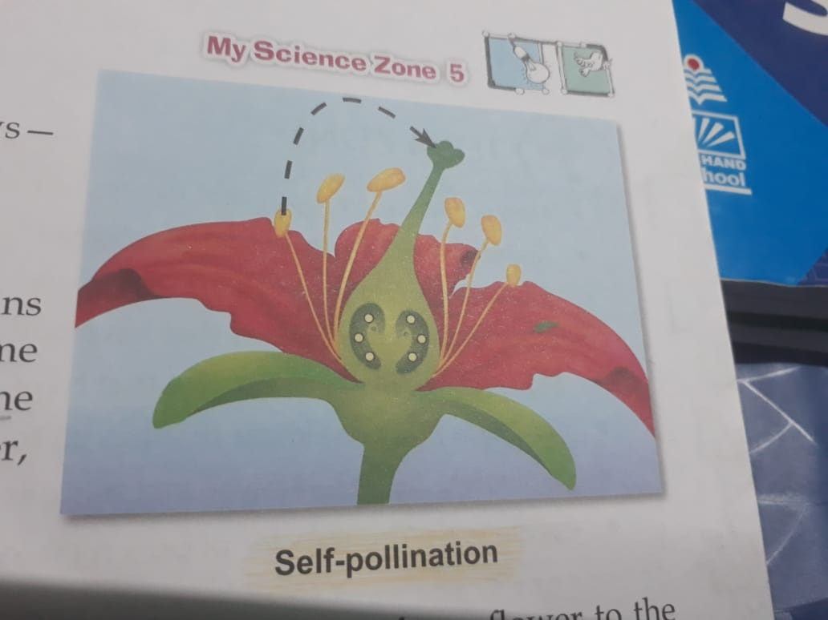

Self – pollination
Exercise 5. Long answer questions.
- The four whorls of a flower are:
Calyx – This is the first whorl of a flower. It consists of a set of green leaf-like structures called sepals. Sepals protect the flower in the bud stage, and the inner parts of the flower in the later stages. They can also prepare food for the plant.

Corolla – This is the second whorl of a flower. It consists of a set of brightly – coloured, leaf – like structures called petals. Petals give colour and fragrance to the flower and are the most noticeable part of it. They help attract insects towards the flower.
Androecium – This is the third whorl of a flower. It consists of the male reproductive part of the flower, called the stamen. Each stamen comprises two parts – filament and anther.

Gynoecium – This is the fourth and the innermost whorl of a flower. It is located at the centre of the flower. It consists of the female reproductive part of the flower called the pistil or carpel. Each pistil comprises three parts – stigma, style and ovary.

- i. Monosexual and bisexual flowers

Monosexual Flowers | Bisexual Flowers
Either male or female reproductive part is present. | Both male or female reproductive parts are present.
They do not have all the four whorls. | All the four whorls are present.
They are incomplete flowers. | They are complete flowers.
e.g. papaya, maize | e.g. gulmohar, hibiscus

ii. Androecium and gynoecium

Androecium | Gynoecium
This is the third whorl of a flower. | This is the fourth and the innermost whorl of a flower.
It consists of the male reproductive part of the flower | It consists of the female reproductive part of the flower
It is composed of one or more stamens. | It is composed of one or more carpels.
Each stamen consists of filament and anther. | Each carpel consists of stigma, style and ovary.
It produces male gametes. | It produces female gametes.

- The transfer of pollen grains from the anther to the stigma of flowers is called pollination.
When a bee visits a flower to collect nectar, the pollen grains from the plant’s anther stick onto its legs, wings, mouth parts etc. When the bee visits another flower of the same kind, the pollen grains from its body may fall on the stigma.

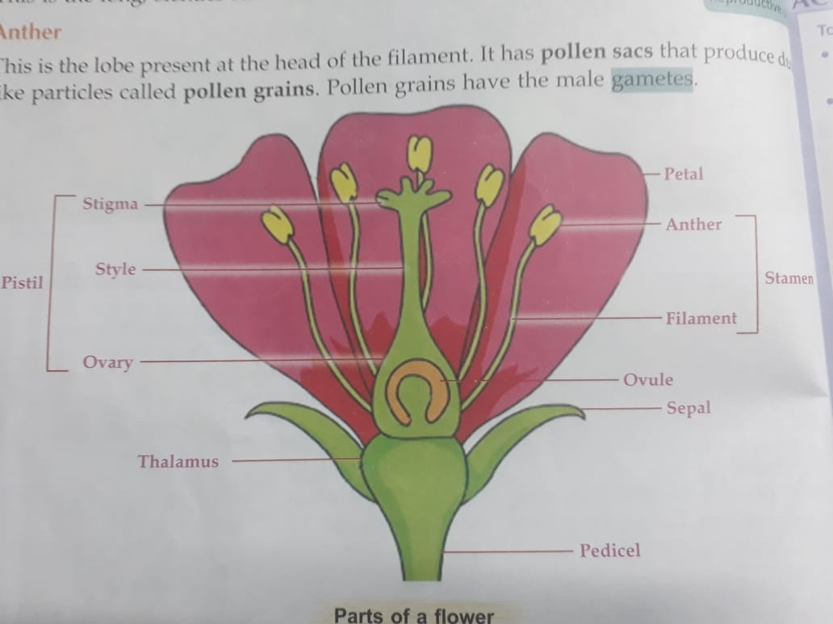
- Stamen ii. Pistil

- The transfer of pollen grains from the anther to the stigma of the same flower or of another flower present on the same plant is called self – pollination. This occurs in plants like the sunflower, orchids, peas etc.
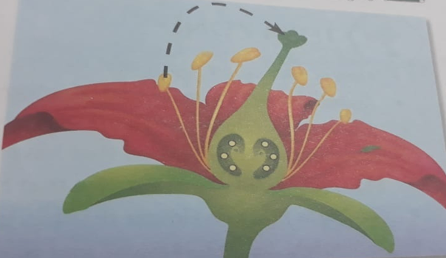

Self – pollination

