ST. THOMAS SCHOOL, DHURWA, RANCHI
SESSION – 2021- 2022 ( THIRD TERM)
SUBJECT – MATHS
CLASS- STD 1
ASSIGNMENT – 12
Work to be done in class work copy
I. Write the following tables in your copy
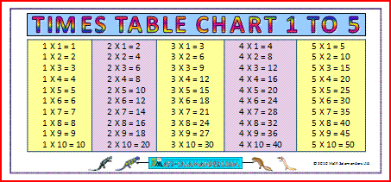
II. Complete the following-
a.
+ = 4
2 + 2 = 4
2 x 2 = 4

b. ++ = 6
2 + 2 + 2 = 6
2 x 3 = 6
c. ++ = 9
3 + 3 + 3 = 9
3 x 3 = 9

d.  + + +  = 16

4 + 4 + 4 + 4 = 16
4 x 4 = 16

III. Observe, say and write:
a. 2 multiplied by 3 is equal to = 6
b. 3 multiplied by 3 is equal to = 9
c. 4 multiplied by 3 is equal to = 12
d. 5 multiplied by 3 is equal to = 15
IV. Multiply and write:
a. 3 X 5 = 15
b. 4 X 10 = 40
c. 0 X 1 = 0
d. 5 X 4 = 20
e. 2 X 1 = 2
V. Fill in the blanks-
a. 1 five is equals to 5.
b. 2 five is equals to 10.
c. Repeated addition is called multiplication .
d. 0 multiplied by any number is equal to 0
e. 1 multiplied by any number is equals to the number itself
VI. Word problems-

1. There are 5 tables and 5
each tables has 4 legs. X 4
How many legs are there in all? 20

2. There are seven cows and 7
each cow has 4 legs . X 4
How many legs are in all? 2 8

