CHAPTER 6
COMPUTER KEYBOARD

EXERCISES

Ex.1 Fill in the blanks. Choose the correct word from the brackets:
keys
- A keyboard has buttons on it. These buttons are called ………………….. (Keys/Switches)
Alphabet keys
- Keys that are used to type alphabets are called ……………………….. (Number keys/Alphabet keys)

- Text cursor can be moved in four directions on the screen with the help of …………………………. (Cursor control keys/ Alphabet keys)
Cursor control keys

Ex.2 Tick () the correct option:(p.46)

- …………………. help us to type commands.
(i) Keys on a keyboard (ii) Buttons on a mouse

- Keys showing letters from A to Z are:
(i) Number keys (ii) Alphabet keys

- Keys showing numbers from 0 to 9 are:
(i) Number keys (ii) Alphabet keys

- Text cursor can be moved up by pressing ……………… key.
(i) Down arrow (ii) Up arrow

- Text cursor can be moved towards the right by pressing …………………… key.
- Right arrow (ii) Left arrow

Ex.3 Mark the alphabet, number and arrow keys with different colours: (p.46)
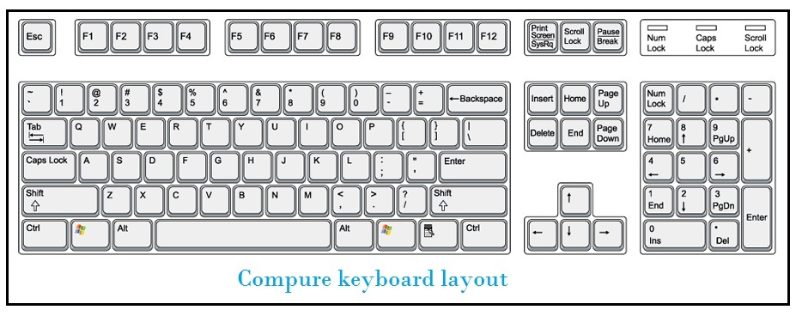

Ex.4 Fun Time on Computer! (p.47)
Type the following sentences on the computer. (Try with your computer)

- My name is ……………..
- I am …………… years old.
- I live in …………….
- I study in ……………………………….. School.

Ex.5 Write your name in the boxes provided and then colour the letters of your name on the keyboard. (p.47) Do it on your own.

Example:

H
L
O
O
C
S

Y
M

